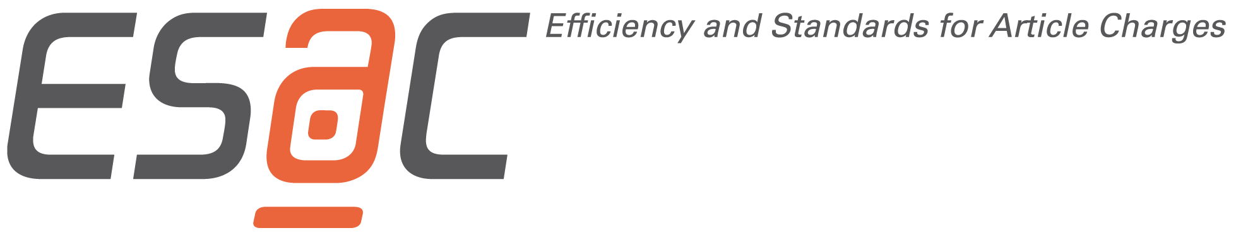
Proposed Workflow Terms for Transformative Agreements
Open access workflows
The parties agree to collaborate to explore the development of streamlined author identification and verification workflows as well as efficient invoicing and reporting processes.
1. Eligible authors
1.1 Authors (“Eligible Authors”) who want to publish OA Articles must be affiliated with one of the Customer Sites.
1.2 Eligible Authors must be the corresponding author and their Customer Site must be stated as their affiliation in the OA Article.
1.3 Eligible Authors can be identified through at least one of the following parameters:
- IP ranges specified by the Customer; and/or
- e-mail domain defined for each institution; and/or
- stating the Customer Site in the author identification workflow; and/or
- persistent identifier, such as Ringgold, ORCID or other recognised institutional identifier as provided by the Eligible Author and published in the article metadata;
and
- affiliation as stated in the article to be published.
2. Obligations of Publisher and Customer
2.1 The publisher shall inform authors about the availability of institutional agreements which secure the coverage of open access publishing fees.
2.2 Articles by authorized authors will be selected for publication in Open Access by default.
2.3 Publisher shall publish the following article types from Eligible Authors as OA Articles under a Creative Commons Attribution (CC-BY) licence without delay upon first publication:
[article types tbd, e.g. original articles and review articles]
2.4 No additional service fees (e.g. colour-in-print, reprints, posters) will be charged under this agreement.
2.5 Publisher, in collaboration with the Customer, shall use reasonable efforts to explore the development of an author verification process as quickly as possible.
2.6 Publisher shall be responsible for the identification of Eligible Authors. lf authors have not stated their eligibility before publication, they are not eligible anymore to publish Open Access under this Agreement if the article has already been published in an eligible Journal.
2.7 Publisher shall label OA Articles as funded by the Customer in the paper itself (e.g. the footnote of the OA Article in the version of record shall state the following “Open access funding provided by [The Customer]”).
2.8 Publisher will notify Customer once an article by an Eligible Author has been identified.
2.9 Customer will verify the eligibility of an article as quickly as possible to ensure the timely production and publication of the article. lf Customer requires more than five (5) business days to approve or reject the eligibility of the article, they will inform Publisher about the delay in the process.
2.10 Publisher will secure that the affiliation of the corresponding author as stated in the article, and based on which Customer verifies eligibility, will not change after approval or rejection. Should, contrary to expectations, an article identified as being eligible not be published, Customer will be notified accordingly and the OA Article will not be invoiced/counted.
2.11 The publisher will deliver article metadata including Open Access license information to CrossRef and other relevant third parties.
3. lnvoicing and Reporting
3.1 Publisher will not directly charge authors whose eligibility has been confirmed.
3.2 Publisher will only invoice for OA Articles that have been accepted for publication (article acceptance) and have been confirmed as eligible by Customer. The invoice/ pre-invoice statement shall include the following details:
- Name and email address of the Author who is affiliated to MPS (must be the corresponding author)
- Full name of Author’s Max Planck affiliation (e.g. institute, department)
- Date of acceptance
- Journal Title
- Article title
- Article type
- DOI and/ or link to the published article
- Amount due
- Discounts and discount group (if applicable)
3.3 Publisher will document how many eligible articles have been published and will communicate this to Customer on a monthly basis. The monthly delivery of article reports will be replaced by a reporting tool to be developed by Publisher. This reporting tool will provide article reports (e. g. a list of accepted articles).
3.4 Publisher shall also provide an annual report of the total number of articles published in conformity with this Agreement. This report shall be provided both in machine readable form in a structured format as comma separated value file format (csv) and in human readable format and shall include the following details:
- Name of the publisher
- Bibliographical metadata (Journal title, journal abbreviation, journal ISSN, volume, issue, pages, article title, authors’ names) or DOI
- Affiliated author, incl. ORCID
- Affiliated author’s institution
- Publication date
- Amount due
- lnvoice date
- lnvoice number
- Optional, if existing: Discount
3.5 Publisher will also provide updates on eligible journals under this Agreement.
3.6 Publisher will deliver article metadata including license information to CrossRef and other relevant parties.
3.7 Publisher will provide Customer with the final (published) versions of eligible articles (pdf full text and xml metadata) by no later than one (1) month after first publication and/ or push full texts to Customer’s central repository via FTP (ftp, ftps, sftp) or SWORD 1.3 protocol.
4. Editorial independence
4.1 Both parties recognise that Customer will not be involved in the editorial processes despite its financial obligations towards Publisher.
4.2 Publisher is not obligated to publish an article submitted by an Eligible Author on the basis of this agreement.
4.3 Customer recognises that the selection of content that is to be published on Publisher’s platform is entirely at Publisher’s discretion. Customer relinquishes all possibly due claims towards Publisher resulting from publisher’s rejection to publish content, either entirely or partially, submitted by an Eligible Author.

