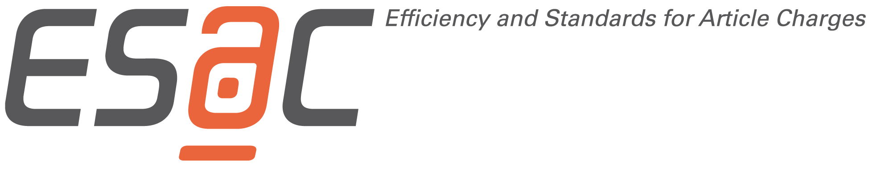
Open Access Service Level Agreement Template

Parties
Publisher XX
and
Institution YY

Object of agreement

YY is an independent, non-profit research organization/ funder…. The primary goal of YY is to ... Authors of YY in conformity with this Agreement are scientists that are affiliated to YY as members of one of its institutes (each, an "Authorized Author"). The YY institutes are listed in Schedule 1. YY has the aim to pay the publication fees for articles ("Articles") published in XX journals out of central funds if the corresponding author is affiliated to YY. The object of this Agreement is to set out the terms and conditions relating to publication of such articles.
XX is a not-for-profit society/ publisher/ open access publisher …. XX publishes journals… at https://www.XXX/ ... XXX assigns a CC-BY license to its publications and a Creative Commons CC0 license to accompanying data.

Contacts
YY Account Administrator
YY Invoicing
XX Account Administrator:

Contract period and termination
This arrangement shall come into effect concerning any unpublished XX Open Access articles accepted for publication following signature of this document by the two parties. Either party may terminate this arrangement for any unconfirmed articles at any time by written notice.

Identification of authorized articles and payment workflow
Both parties agree to work together to develop a workflow by mutual agreement to identify XX Open Access approved Articles that have been submitted by YY Authorized Authors. XX will strive to clearly indicate the availability of an institutional funding agreement to YY affiliates both within their submitting process and on their website.
YY Authorized Authors can be identified through at least one of the following parameters:
• IP ranges specified by the Customer; and/or
• e-mail domain (‘@YY.de’, list possible domain variations)
• persistent identifier, such as Ringgold, ORCID or other recognized institutional identifier as provided by the Authorized Author and published in the article metadata; and/or
• affiliation as stated in the article to be published.

When submissions by YY Authorized Authors are identified in the publication system, XX shall send an email alert to the YY invoicing contact requesting verification of submissions from Authorized Authors. The submission alert includes the following details:
- Name and email address of the Author who is affiliated to YY
- Full name of Author’s affiliation (e.g. institute, department)
- Submission Date
- Journal Title
- Manuscript ID (if applicable)
- Article title
- Article type
- Amount of article processing charges
- Discounts and discount group (if applicable)

Upon acceptance for publication of verified submissions, the subsequent invoice/ pre-invoice statement shall include the following details:
- Name and email address of the Author who is affiliated to YY
- Full name of Author’s affiliation (e.g. institute, department)
- Date of acceptance
- Journal Title
- Article title
- DOI and/ or link to the published article
- Amount due
- Discounts and discount group (if applicable)

The YY Account Administrator shall respond within a reasonable period not exceeding 10 business days. The parties will work together to develop a streamlined identification process which may include authentication by IP address.
XX shall label OA Articles as funded by YY in the XX Publication itself (e.g. the footnote of
the OA Article in the version of record shall state the following "Open access funding provided by
YY").

List of XX OA prices and discounts
XX will inform YY at least one month in advance about any changes in pricing and discounting. Current XX journals and article publication fees applicable are stated in Schedule 2.

Copyright statement and Conditions for Authors
Authors of YY publishing with XX Open Access retain copyright and XX licenses these articles under the Creative Commons Attribution license CC-BY (http://creativecommons.org/licenses/by/3.0/).

Annual Account performance reports
In addition to regular Account statements, XX shall provide annual reports of the total number of Articles published in conformity with this Agreement. This list shall be provided both in machine readable form in a structured format as comma separated value file format (csv) and in human readable format and shall include the following details:

- Name of the publisher
- Bibliographic metadata (Journal title, journal abbreviation, journal ISSN, volume, issue, pages, article title, authors’ names) or DOI
- Affiliated author, incl. ORCID
- Affiliated author’s institution
- Publication date
- Amount due
- Invoice date
- Invoice number

Optional, if existing:
- Discount
- …

The annual reports shall include the time span of the last calendar year and shall be delivered in the first quarter of the following year.

YY will also deliver article metadata including license information to CrossRef and other relevant third parties.

Repository
XX ensures the delivery of each Article published under this agreement to YY institutional repository (specified / SWORD…)

Liability
Neither party excludes or limits liability to the other party for death or personal injury caused by its own negligence or any other liability the exclusion or limitation of which is expressly prohibited by law.

Governing Law
This Agreement shall be construed and interpreted pursuant to the laws of the YY country applicable to contracts wholly entered into and performed in the YY country. Any legal action, suit or proceeding arising out of or relating to this Agreement or the breach thereof shall be instituted in a court of competent jurisdiction in the YY country and each party hereby consents and submits to the personal jurisdiction of such court, waives any objection to venue in such court and consents to the service of process by registered or certified mail, return receipt requested, at the last known address of such party.

Severability
In the event that any one or more of the provisions contained herein shall, for any reason, be held to be invalid, illegal, or unenforceable in any respect, such invalidity, illegality, or unenforceability shall not affect any other provision of this Agreement, but, to the extent permitted by law, this Agreement shall be construed as if such invalid, illegal, or unenforceable provision had never been contained herein.

Waivers
No modification, amendment or waiver of any provisions shall be valid unless in writing. Any waiver in one or more instances by either of the parties of any breach by the other of any terms or provisions contained in this Agreement shall not be considered a waiver of any succeeding or preceding breach.

The parties agree to the terms of this Agreement.

………………………………………………………………
XX

………………………………………………………………
YY

Schedule 1

Sites/ Institutes of YY (eligible for central billing of OA publication charges)

Currently these are the following sites/institutions (as of date):

Name | Main Location | IP Range

Schedule 2

XX Journals as of (date)

Journal Title | eISSN | Article Price

